**WEB :**

System Implementation Structures are the lowest-level system elements in the system hierarchy (system breakdown structure).The implementation Structure starts with how the pages are displayed as soon as the application starts running.

The application begins with the Home Page, Which asks the authorized user(Pharmacist/Manager/Executive Manager) to login.

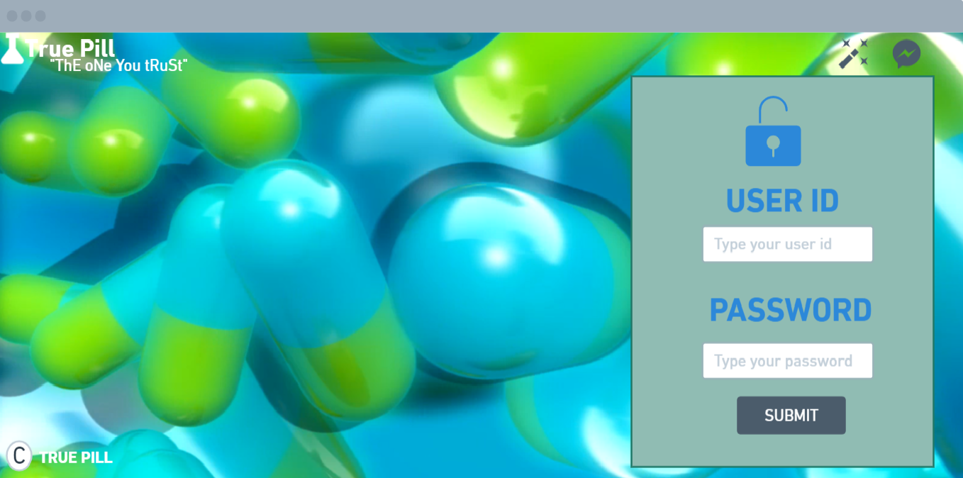

If the user logged in is a Pharmacist, then the homepage of the Pharmacist is displayed.

**string sql= select * from pharmacist where username==?&& password==?**

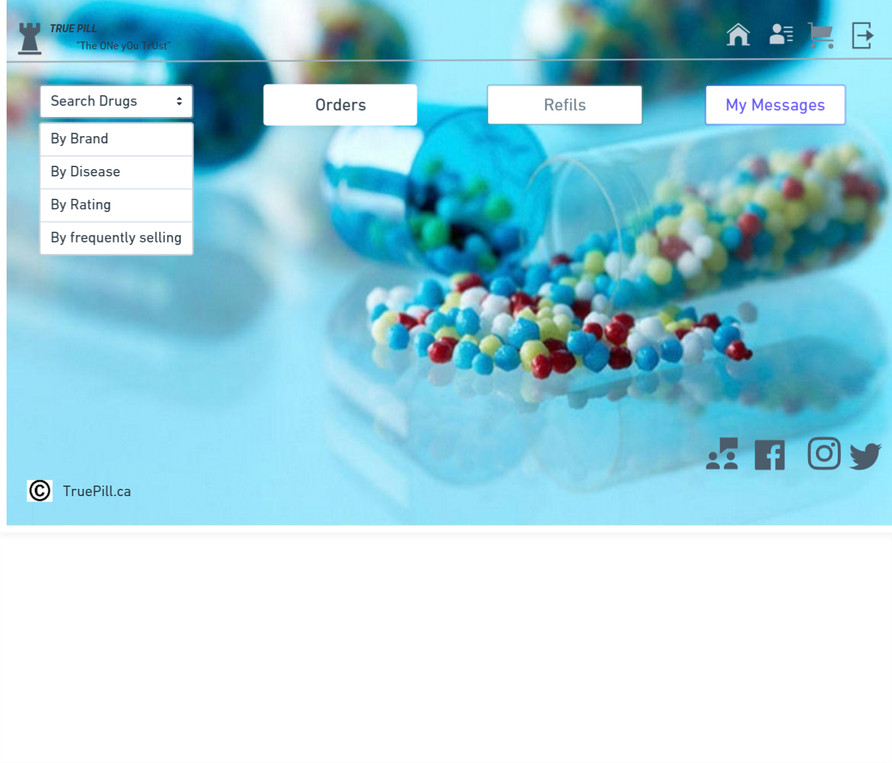

* The Pharmacist would be able to Search Products, Sale, Manage the Orders(Cart) and Manage Inventory(In Refills)
* The orders placed by a particular pharmacist would be listed out in the Cart tab, where we could Add/ delete a product before we checkout and finally Proceed to checkout and pay, get a copy of the receipt.

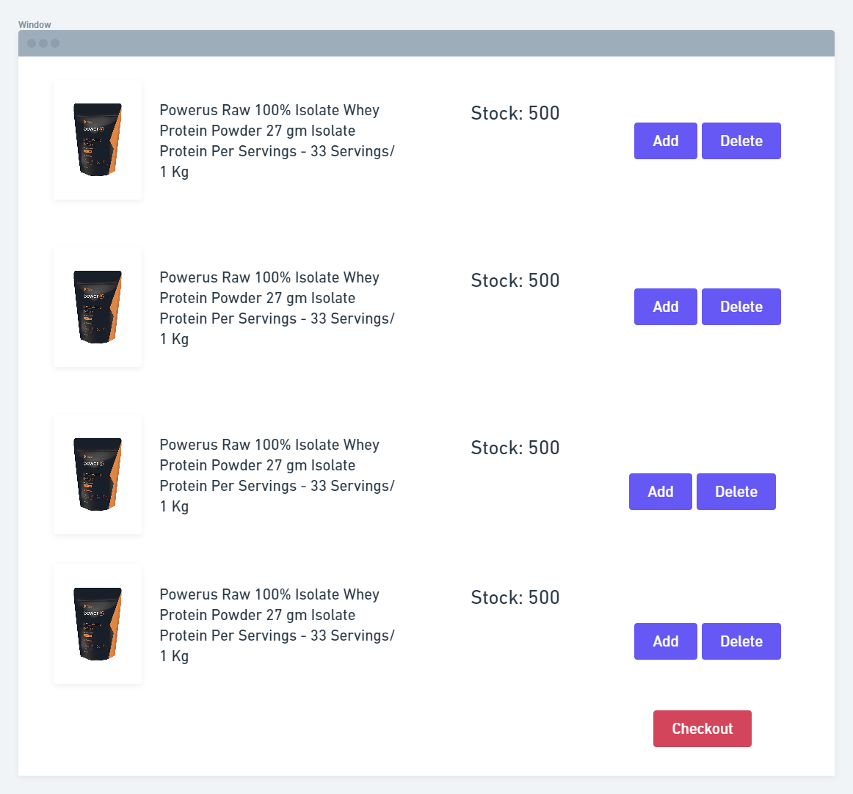

* Pharmacists can also update the inventory from the refills tab. When a pharmacist has any item out of stock and wanted to place an order with the supplier, that particular list would be updated through the Refills tab, where the pharmacist could customize the number of products needed.

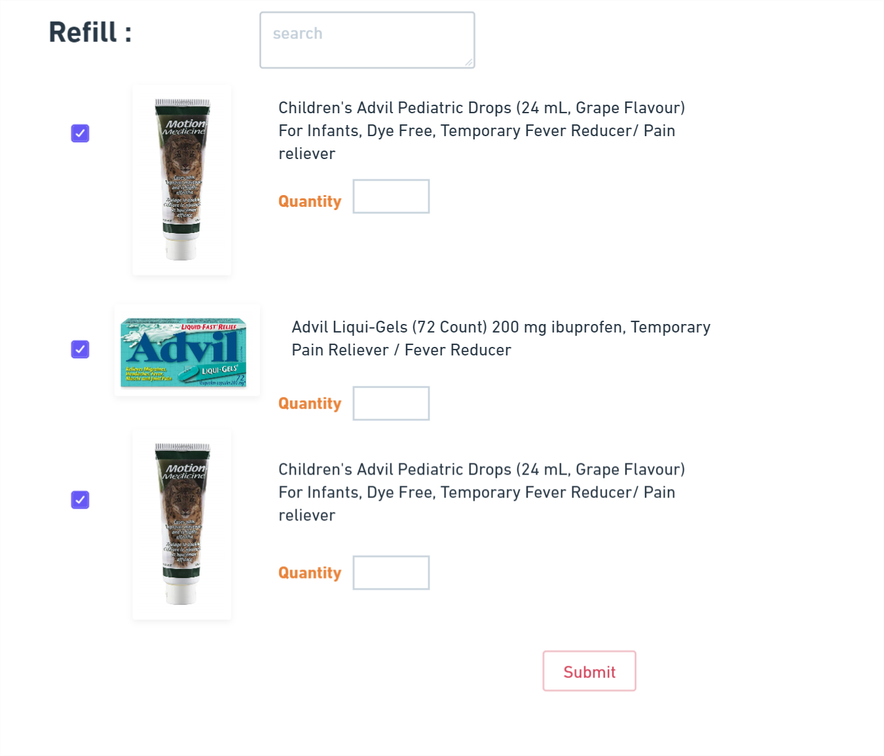

When the logged in user is an Admin

**string sql= select * from admin where username==?&& password==?**

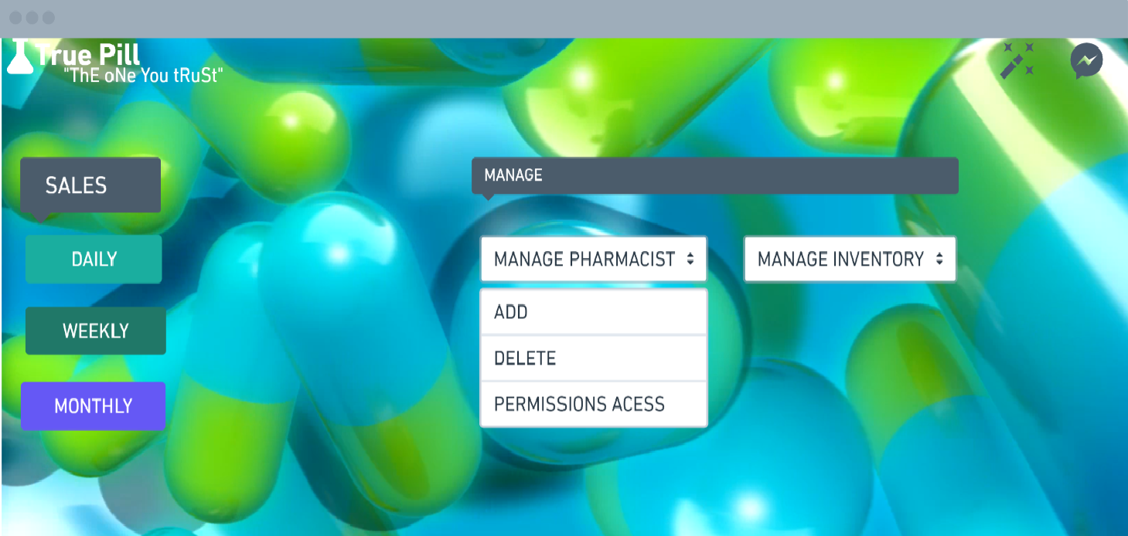

* Admin will have to Approve the Inventory requirements which the Pharmacist has added, Only then the orders would go to the Suppliers and once the orders are being obtained from suppliers, the pharmacist will update the inventory list with the new stock.
* Admin will get the Sales Reports on the Daily, Weekly and Monthly basis.

When the User Logged in is an SuperAdmin(Executive Manager)

**string sql= select * from superadmin where username==?&& password==?**

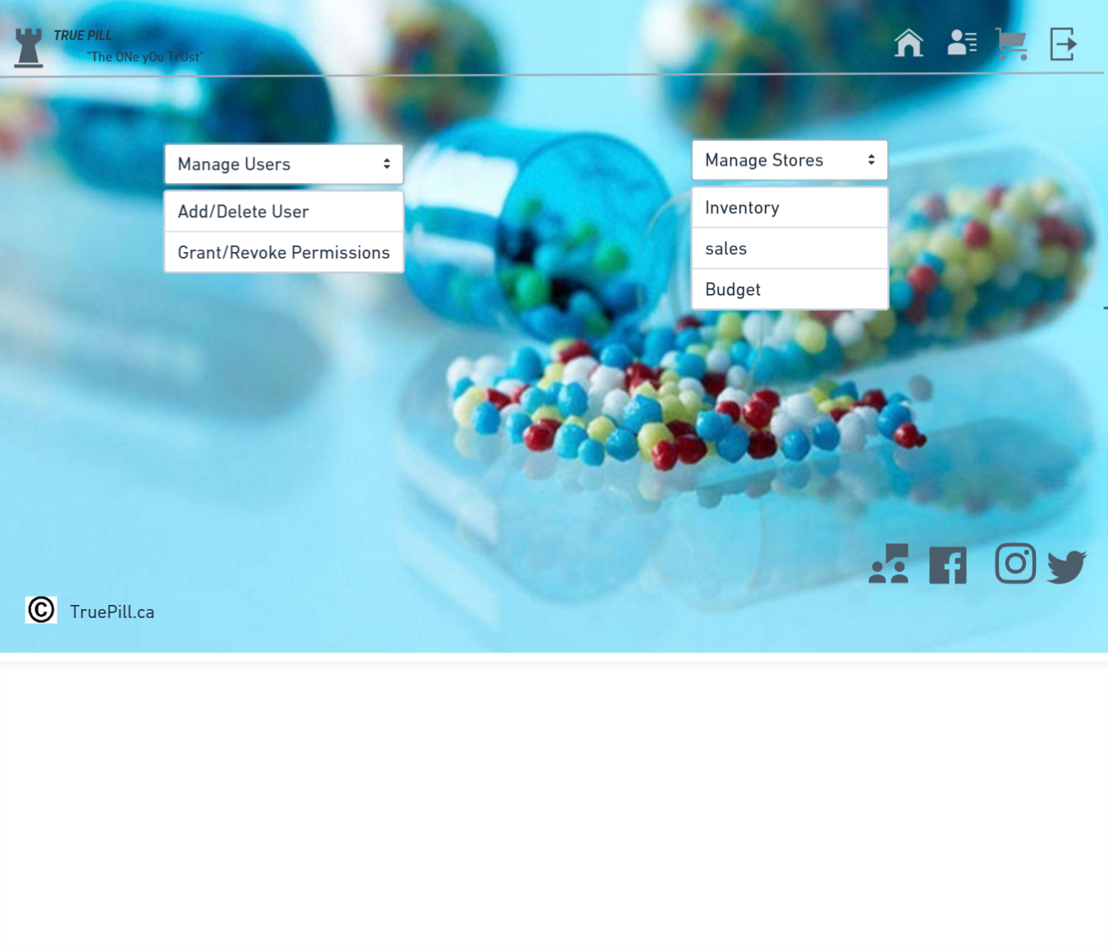**ANDROID**

This page is for the pharmacist, store manager and executive manager so that they can login and perform the necessary activities.

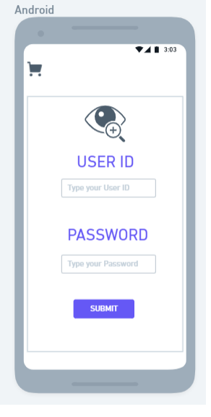

This is used by the store manager and executive manager to check the sales report and to add or remove a pharmacist

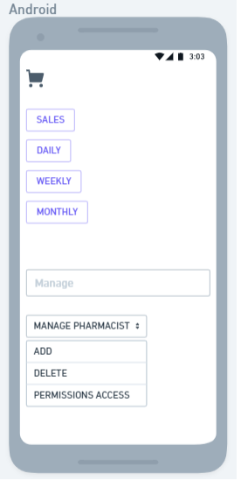

This page displays the list of products that are added to the checkout page.

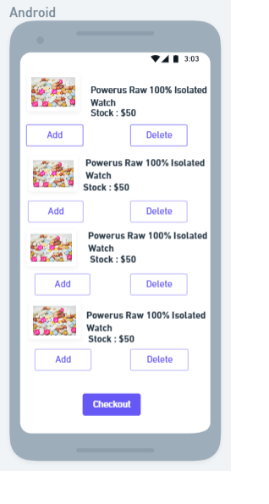

This page is used to display the list of employees/pharmacists who are working in the store which contains their designation and store id.

The Super Admin/Executive Manager will be able to Add/Delete the Users, Provide Permissions to the users. Also multiple stores can be managed by each category such as the Inventory, Sales, Budget for each store depending on the Id and the store location.

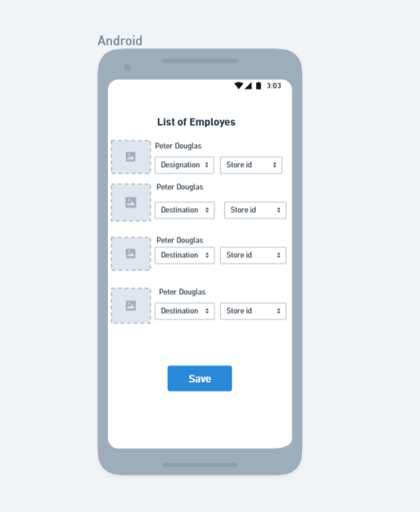CONCLUSION The development of desktop application and android app of Drug Management System involved many phases. The approach used in is project is a top-down one concentrating on what first, then how and moving to successive levels of details. The first phase started with a detailed study of the problems and prospects of a lot of paper work in drug management. In the course of this study, many problems were discovered to have hindered the effectiveness of the existing manual system. These problems, information needs and activities were documented and later used as the basic phase was concerned primarily with the specification’s drug store sector. During this phase, strict adherence was made on proven software engineering principles and practice. To implement this design, a computer program was then written in Android studio. It is hoped that effective implementation of this software product would eliminate many problems discovered